**Third Year Project 2017**

**Sports Diary**

Robert Deegan

G00320583@gmit.ie

<https://github.com/RobbieDeegan/Third-Year-Final-Project>

Project Design Documentation

Table of Contents

1. Introduction
2. Technology Used and Why
3. Design Methodology
4. System Requirements
5. Limitations
6. Known Bugs
7. Conclusions

11. References

12. User Guide & Video Demo

Introduction

When I was trying to come up with ideas for this project, I first looked at possible ideas that I would like to see in the google store or apple app store and something that I could use myself on a regular basis. I first looked at the idea of making a game such as a first person adventure game or a platformer but decided against that idea early on as I struggled to get a decent understanding of the Unity 5 game engine. I then started to look at something that I wanted to use and actually would use on a regular basis. I’ve been playing amateur soccer for well over ten years at this point in time. Over the years I’ve come to notice that the [website](http://galwayfa.ie/) in which I get the schedule for the season or year in question was very poorly designed and difficult to navigate around to find out when and where my matches were and who they were against. The site has been updated recently and the UI is much improved but there is still the task of looking through menus to find the information you want. My idea is to simplify that by designing a phone application in order to keep a list of all of the users matches and training sessions for their chosen sport. It wouldn’t require an internet connection to access a website. The user would simply insert all the matches into the list and delete them as they go by. The user will also be able to store the times of their training sessions so they keep all their sporting events organised. They could even add reminders for professional matches that would be on the television. To some up it shortly I will attempt to make a sporting diary to stay organised.

Technology Used and Why

Since I was going to be developing this app for phones I decided to use the Ionic framework that we had learned in the Mobile Applications Development module in our Second year of this course. I remember it being relatively straight forward and I has passed the module as well so I felt confident using this framework. At the time I had used Ionic it was based around JavaScript and AngularJS. To my surprise the technology had been updated too Ionic 2 and now uses TypeScript instead of JavaScript, which isn’t a huge change they’re still very similar.

Ionic provides some good starter templates to use to get you up and running. There is no need to worry about styling your app as its all included when you download the templates. All the ground work has already been put in to allow the programmer to focus on the main functionality of the application.

It’s also serves as a way to develop for both android and iOS applications.

I used Visual Code as my IDE for the project. It was quickly become my favourite IDE to work with due to its simple layout and built in terminal/command line tool at the bottom to keep everything within the program. It’s also very handy to have the built in git extension to serve as a way to commit changes to the repository without leaving the program. The extension manager is also very well done and will even recommend extensions you may need based on what your programming. Overall I’ve think it’s a fantastic editor and will defiantly be using it again in the future.

Design Methodology

I wanted to stick with a fairly simple design and layout as to keep the application simple to use and intuitive. I went the tabs template that Ionic uses to give me a start with three tabs that you can switch and navigate between. I removed one of them and went with a page for displaying the added events in a list. The second tab would be used to add new events to the list. The navigation between the pages would be done by a button in the top left corner and when you add a new event it will switch back to the list of events.

Once the events are shown in the list they can be delete by swiping to the left on an event or holding it down. A red delete button will appear and the user can tab it to delete the event once its completed.

The list will be stored in the local storage of the device or when being run in the browser as an array of strings with each event being a string.

System Requirements

The app is built for android and has been built for:

Android 4.4 (KitKat)

Android 5.0 (Lollipop)

Android 5.5 (Lollipop)

Android 6.0 (Marshmallow)

Android 7.0 (Nougat)

Android 7.1.1 (Nougat)

Only tested on my own phone which had android 6.0 (Marshmallow).

There is no need for an internet connection as it is local storage on the device.

Limitations

This application will be limited in what it can. It has no access to the internet that could be used for authentication for keeping your information private.

The application itself is very simple with not a whole lot of functionality.

The event is store as one name or string with no real layout or easy way to organise the events.

Known Bugs

There isn’t much that could of went wrong with this design but unfortunately things did go wrong. The events are being added to the local storage as they should be in an array. When testing it with the ionic serve feature in Ionic 2 which runs the application as a web app really, I can see in the developer options that the events are indeed being added to the local storage.

Unfortunately, I cannot get the array of events to output to the list page.

Conclusions

This project is nowhere near the standard that’s required. At the start of the project I attempted to make a game in the Unity engine which didn’t go to plan as I felt at the time that I wanted to stick with what I knew and not dive into something new. Unfortunately, it turns out that Ionic 2 was something almost completely new to me. I didn’t do enough research at the start in order to find out what I was getting myself into and what was required in order to get my idea to work.

The ionic framework is constantly being updated, almost monthly by the looks of it, which is where my struggles started. I would be looking through tutorials of how to do a certain part of the project, only to find out that it was outdated and not included in the ionic version I had installed. My first idea when starting the Ionic application was to make a soccer statistics tracking app that would help you keep track of how many games you have played, goals you have scored and yellow or red cards you had received. I felt it was a good idea as it’s something I would have used myself. The method I was using included SQLite to serve as the database to hold all the stats, which turned out not to work in my version of Ionic which had me confused for weeks not knowing why it wouldn’t work.

Testing the app with the ionic serve function also wasn’t helping me as the storage functionality has been removed from browser testing a few months ago which I didn’t find out for a good while.

The current state of the project is a result of me spending way too much time on the previous idea and ultimately running short of time. My lack of research left me desperately searching for answers and not finding any. When I taught I had found some answers, they turned out to no longer be valid or included in the ionic framework anymore.

I’ve accepted that the project isn’t anywhere close the standard needed. I put myself in a hole that I couldn’t get out of. I also didn’t use the help of Patrick Mannion my project supervisor which I know realise was the biggest mistake of all.

This project has turned out to be the biggest and probably the most important learning experience of my three years in this course and is nowhere near the standard of work I know I can produce. More refinement and research was needed and a much better use and understanding of time management. I certainly didn’t work to my strengths in programming which leans towards Java and C.

I’m certainly not happy with my work and am ashamed at the final result and can only hope I can put it right again and show that I can produce a quality application.

I will learn from these mistakes and experiences that I have made and make sure not to make them again.

References

* <https://unity3d.com/> (For early attempts at making a game)
* <http://ionicframework.com/docs/intro/installation/>
* <https://ionicframework.com/docs/>
* <https://github.com/driftyco>
* <https://www.w3schools.com/sql/>
* <https://sqlite.org/>
* <https://www.joshmorony.com/beginners-guide-to-getting-started-with-ionic-2/>
* <https://developer.android.com/studio/index.html>
* <https://code.visualstudio.com/> (Best IDE I’ve ever used)
* <http://stackoverflow.com/search?q=ionic+2+sql> (I’ve been to so many stack over flow threads I couldn’t include them all)
* <https://github.com/RobbieDeegan/Third-Year-Final-Project>

User Guide

Get the android apk from the projects github repository and install it to an Android phone with Android 4.4 KitKat or later.

The first page would display the list of events if it worked correctly. To then add an event, click the add button in the top right hand corner of the screen. This will bring you to the second page where you can type in your new event. Press add to your list to add the event which will redirect you back to the first page.

.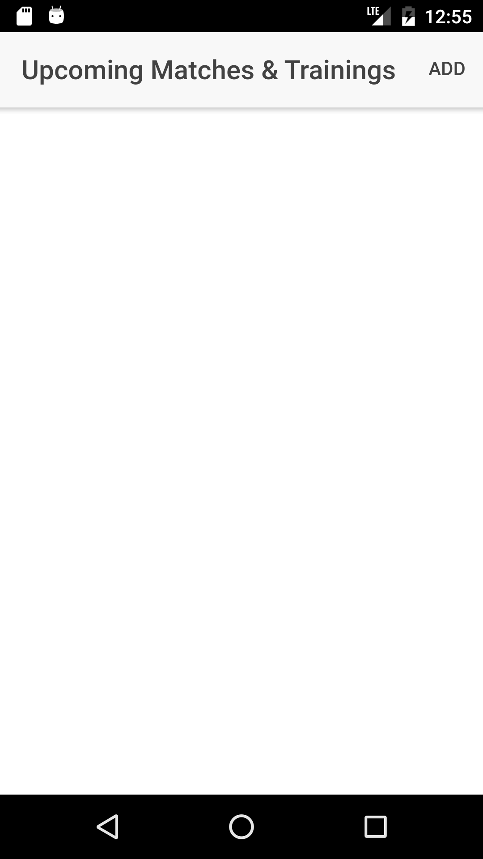 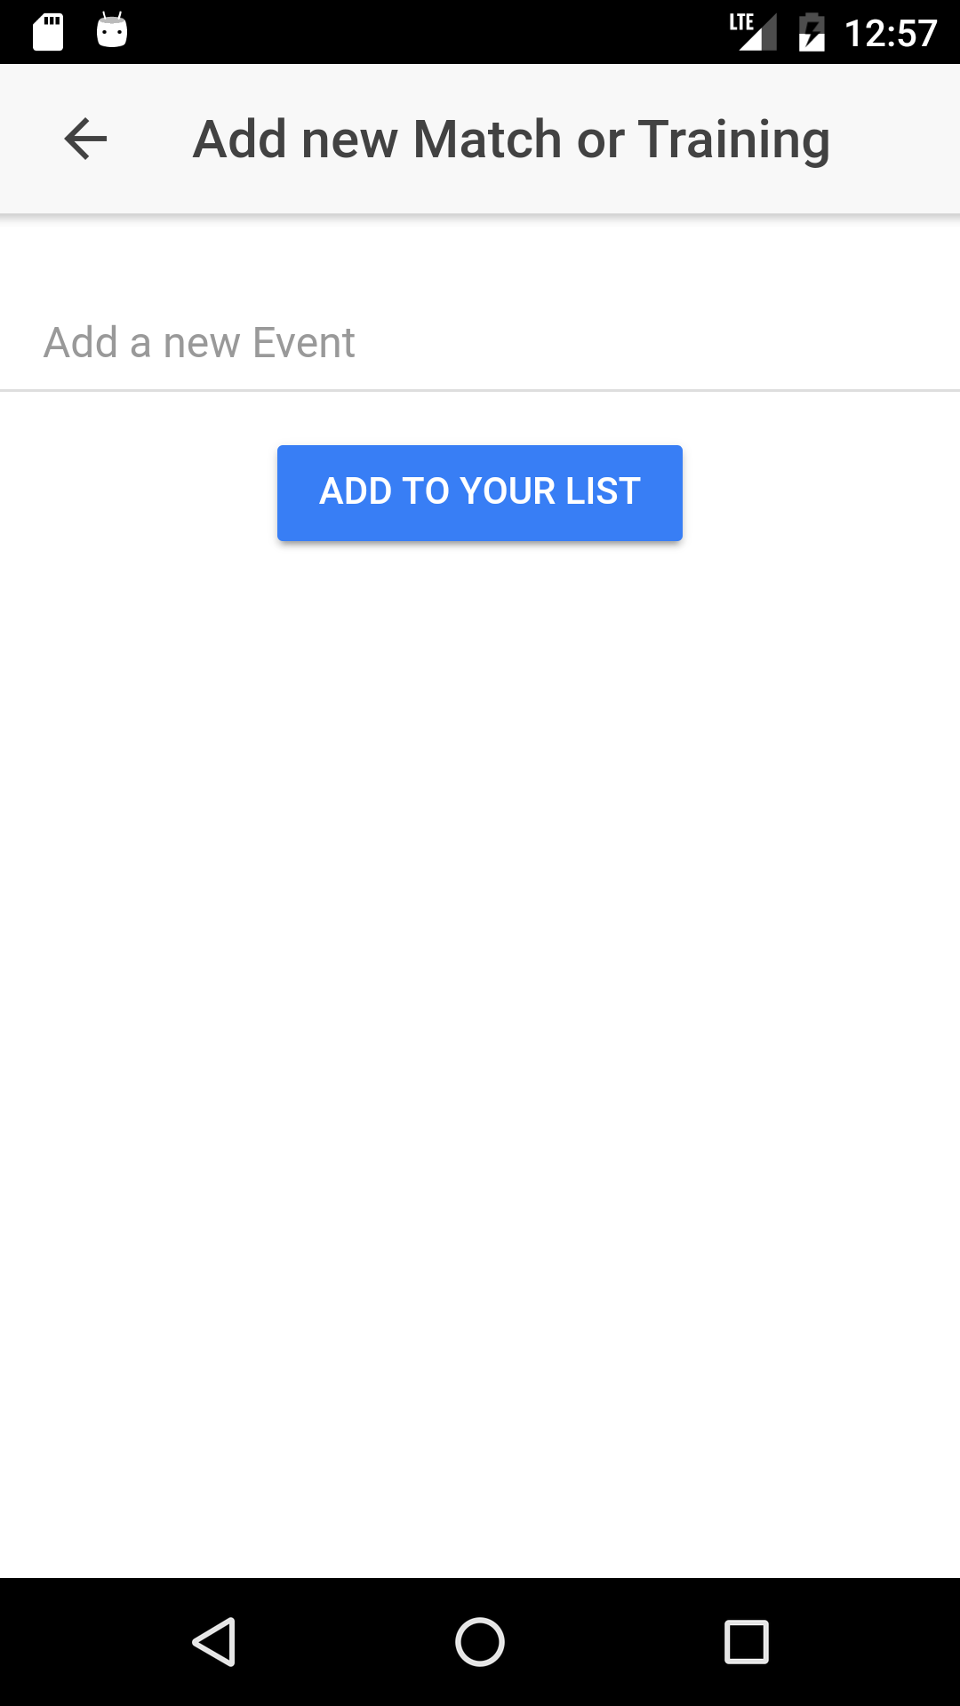

To run on a computer, you will need to have ionic installed on your machine. To do this you will need the current version on Node.js found at <https://nodejs.org/en/>. After that you will need to go to your terminal for MacOs or command prompt for windows and follow the instructions at <https://ionicframework.com/docs/intro/installation/>. Once that’s all installed, clone or download the repository from the project github link. Navigate to the project file in terminal or command prompt and type ionic serve to run the application on a browser through the local host.

Video Demo

<https://www.dropbox.com/home?preview=VID_20170424_011524.mp4>